ContactManagement_Verify Contact notes _Instance44_12-Jul-2018_05-59-21_AM_SingleSignOn.png

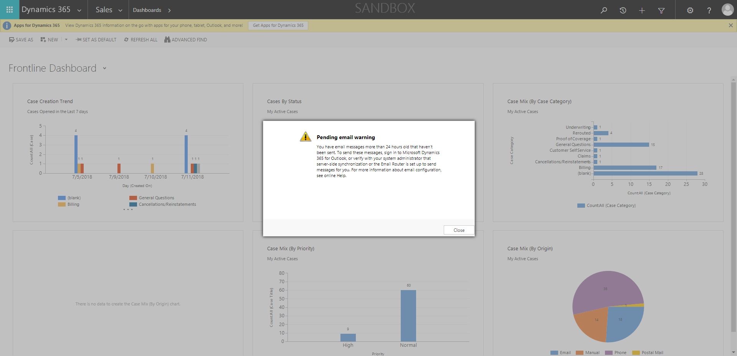

ContactManagement_Verify Contact notes _Instance44_12-Jul-2018_05-59-05_AM_MouseClickActiononStaleElement.png



ContactManagement_Verify Contact notes _Instance44_12-Jul-2018_06-00-40_AM_VerifyingAllNotesofanindividual.png

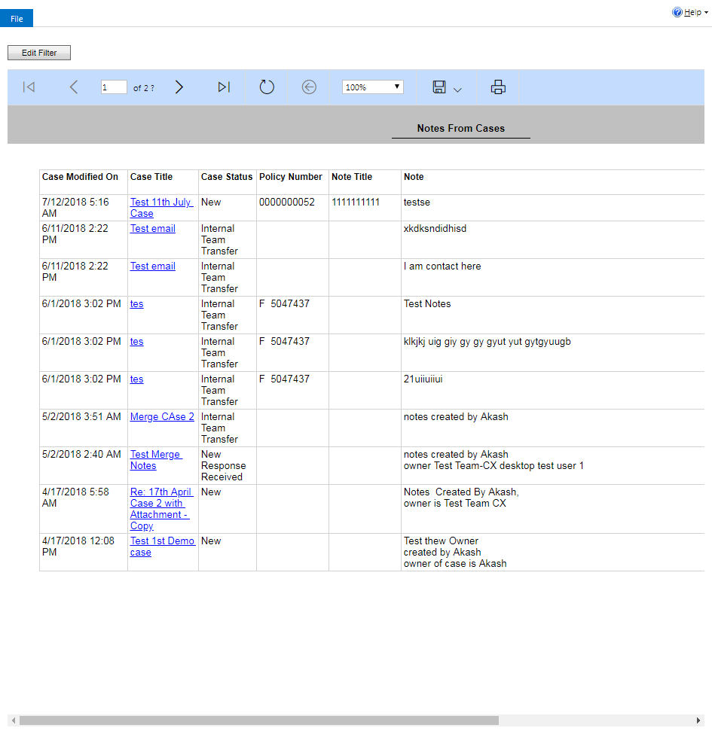

ContactManagement_Verify Contact notes _Instance44_12-Jul-2018_05-59-06_AM_EnterTextAction.png



ContactManagement_Verify Contact notes _Instance44_12-Jul-2018_05-59-25_AM_SingleSignOn.png

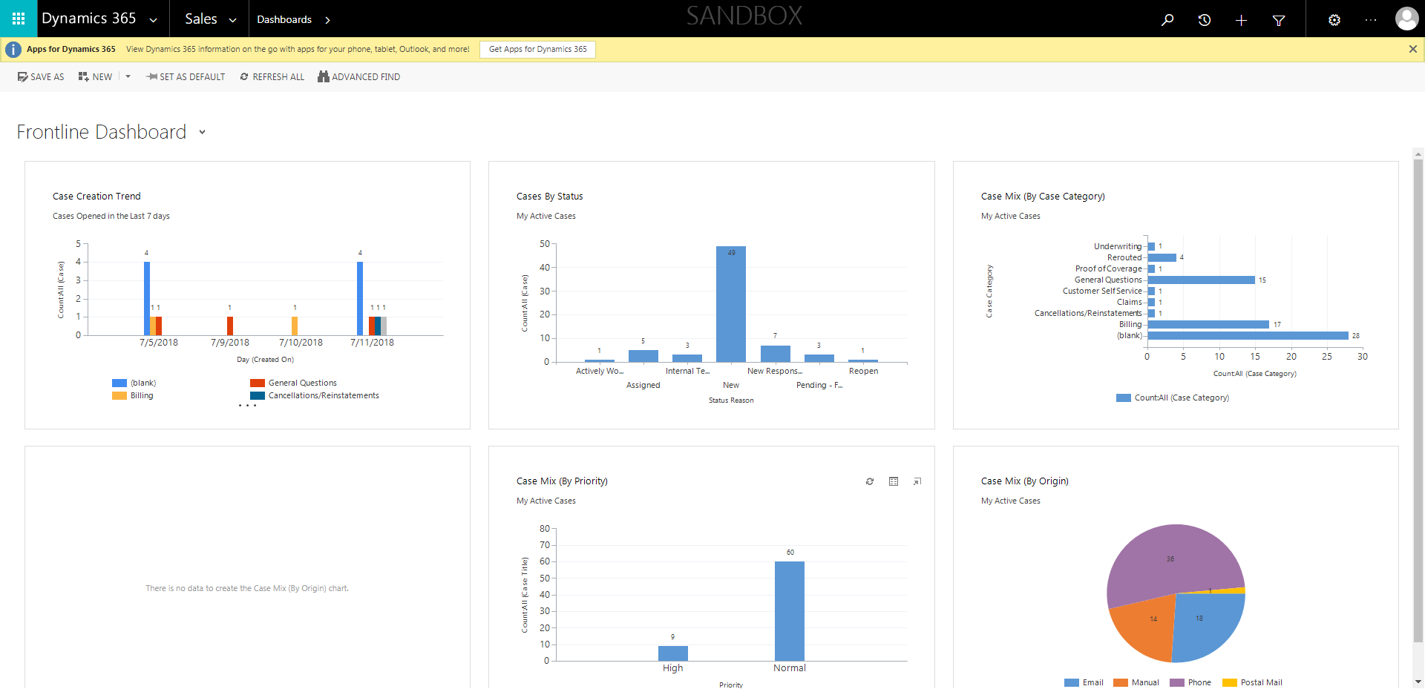

ContactManagement_Verify Contact notes _Instance44_12-Jul-2018_05-59-08_AM_MouseClickActiononStaleElement.png

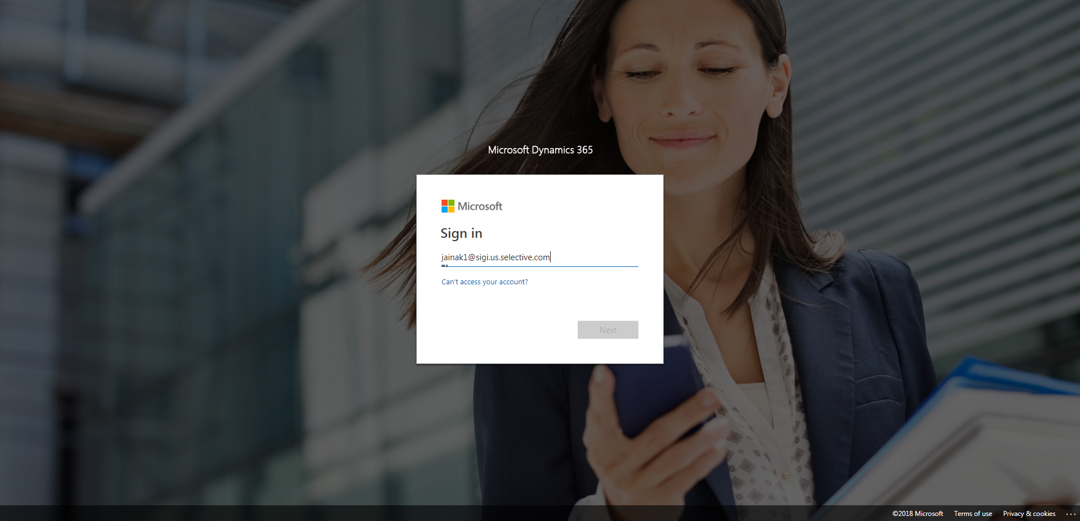

ContactManagement_Verify Contact notes _Instance44_12-Jul-2018_06-00-30_AM_Validatingcontactentitynavigation.png

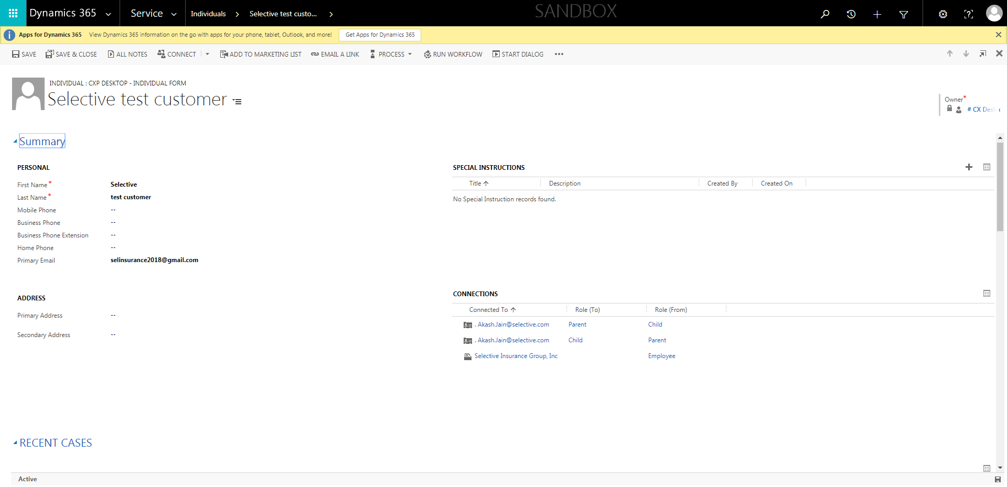

ContactManagement_Verify Contact notes _Instance44_12-Jul-2018_06-00-38_AM_VerifyingLatestNotesofanindividual.png

